MOOC Planner
PHASE I Topic and Learning Outcomes
Unit or MOOC Topic:

Desired Outcomes (knowledge, concepts, skills, and abilities that learners will gain)
Evidence of Outcomes
By the end of this experience they will (know and be able to) … | As evidenced by… (e.g., describe your ideas for specific exercises, discussions, signature assignments, etc.)
Assessment Plan: How will you and the learner determine if the learning that is taking place is of sufficient quality?

PHASE II Content Curation, Session Materials, and Learning Experience Design
What can I use that was created by other people? What do I need to create from scratch? What additional resources are available online? What will students create?
I will use (e.g. OER, 2.0 tools) | What I need to create (e.g., overviews, assignment descriptions and directions, criteria for excellence, discussion prompts, handouts) | The students will create
Outline and Description of the Learning Experience: What will learners do, in what order, how does the plan support their learning? This is an outline, but be specific.
Session I: [Insert title]
Overview, Objectives, and Opportunities (Big Questions and Big Ideas)

Readings and Viewings

Do: Assignments (opportunities to put what they’ve learned into action)

Reflect: Discussion (opportunities to network, compare, debate, and collaborate)

Session I: [Insert title]
Overview, Objectives, and Opportunities (Big Questions and Big Ideas)

Readings and Viewings

Do: Assignments (opportunities to put what they’ve learned into action)

Reflect: Discussion (opportunities to network, compare, debate, and collaborate)

How to Design a MOOC

Topic
What’s the MOOC about? What is the overarching purpose or impetus? Why is it interesting and important? Who is best suited for it? For example, is it a beginner-level course or does it presume prior knowledge and skills? What is the nature of the experience? Is it intended to be self-paced, geared for anybody who is interested in the topic, a companion to a formal course, is there an option for certificate or credit?

Goals and Evidence
What can the learner expect to know and be able to do by the end of the course? From the perspective of social networking, with whom will they have become acquainted? Each learning goal should have at least one corresponding piece of evidence, product(s) of participant work that demonstrate progress toward the goal. For example, if the topic is financial planning and the goal is to live within one’s means, a product of work would be a budget spreadsheet comparing planned and actual spending. For a composer the evidence would be a musical score, and for a musician it would be an audio recording.
NOTE: Sometimes a work product provides evidence for more than one goal. If so, make a note of it in the “evidence” field for each goal.

Learning Sequence
A good MOOC is more than a collection of video lectures and readings; it provides the learners to do things that put what they are learning into action. It’s also helpful to build in opportunities for social learning, such as discussions and peer feedback.

Assessment
Evaluation often takes place at the very end, when there is little or no opportunity for improvement. What’s your plan for assessing learning along the way? How will the students know how they are doing? Some learners are overestimate the quality of their work, while others underestimate their potential. What strategies will you use to involve the students in self-assessment and help them develop a more accurate perception of their performance and growth, and to prompt them to take responsibility for the quality of their work?

Relevant Resources and Technologies
Take time to browse the web and OER repositories to look for gems. Is there an engaging video on YouTube created by an expert in the field? Are there simulations or games that would engage students in interactive learning and help them practice skills and abilities that you want them to develop?
Are there online tools that could engage students in the development of their own work products and/or learning resources? The following diagram illustrates how emerging technologies can further learning.
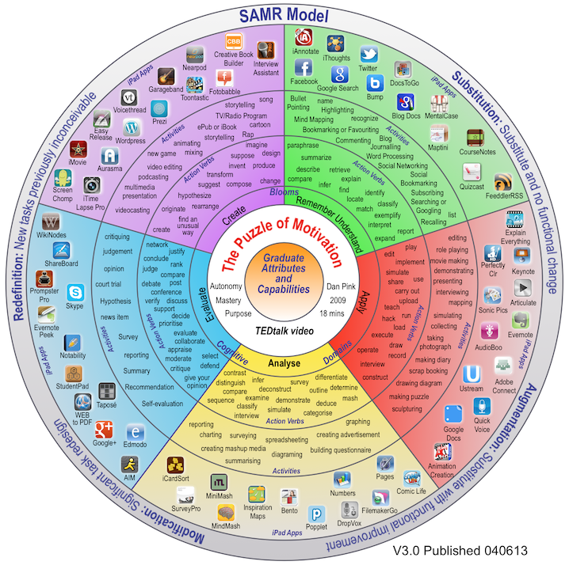
Source: http://padagogy.net/?p=874

Learning Experience Design
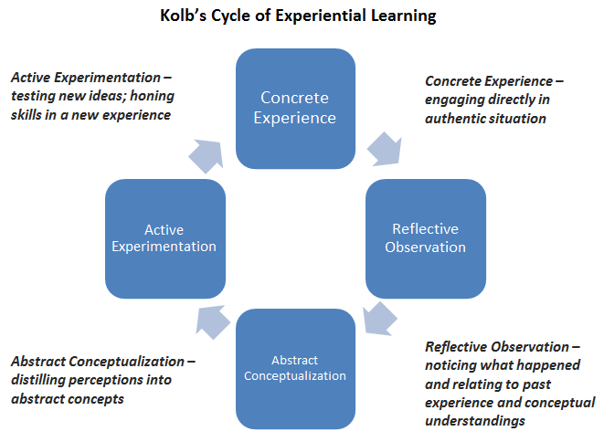
Start with the evidence and plan backwards. What will you have the learner(s) do to generate this evidence? What are the components of the learning experience? Is this a sequence of steps that need to take place in a set order, or can the experiences take place in any sequence? What work will be done online, face-to-face, in a classroom, on location, etc.?
Are you offering a range of experiences so that everyone has an opportunity to learn? Is the experience designed to take learners through an upward spiral or cycle of learning?
What resources and support will learners need to achieve these outcomes? Will you teach and/or facilitate, or is this a set of self-paced resources? Are there ready-made resources (e.g., books, software tutorials, websites) that you can use or draw upon? Are there resources (handouts, presentations, worksheets, etc.) that you need to develop? Do you want to create a multi-media simulation, and therefore need to work with designers and programmers?
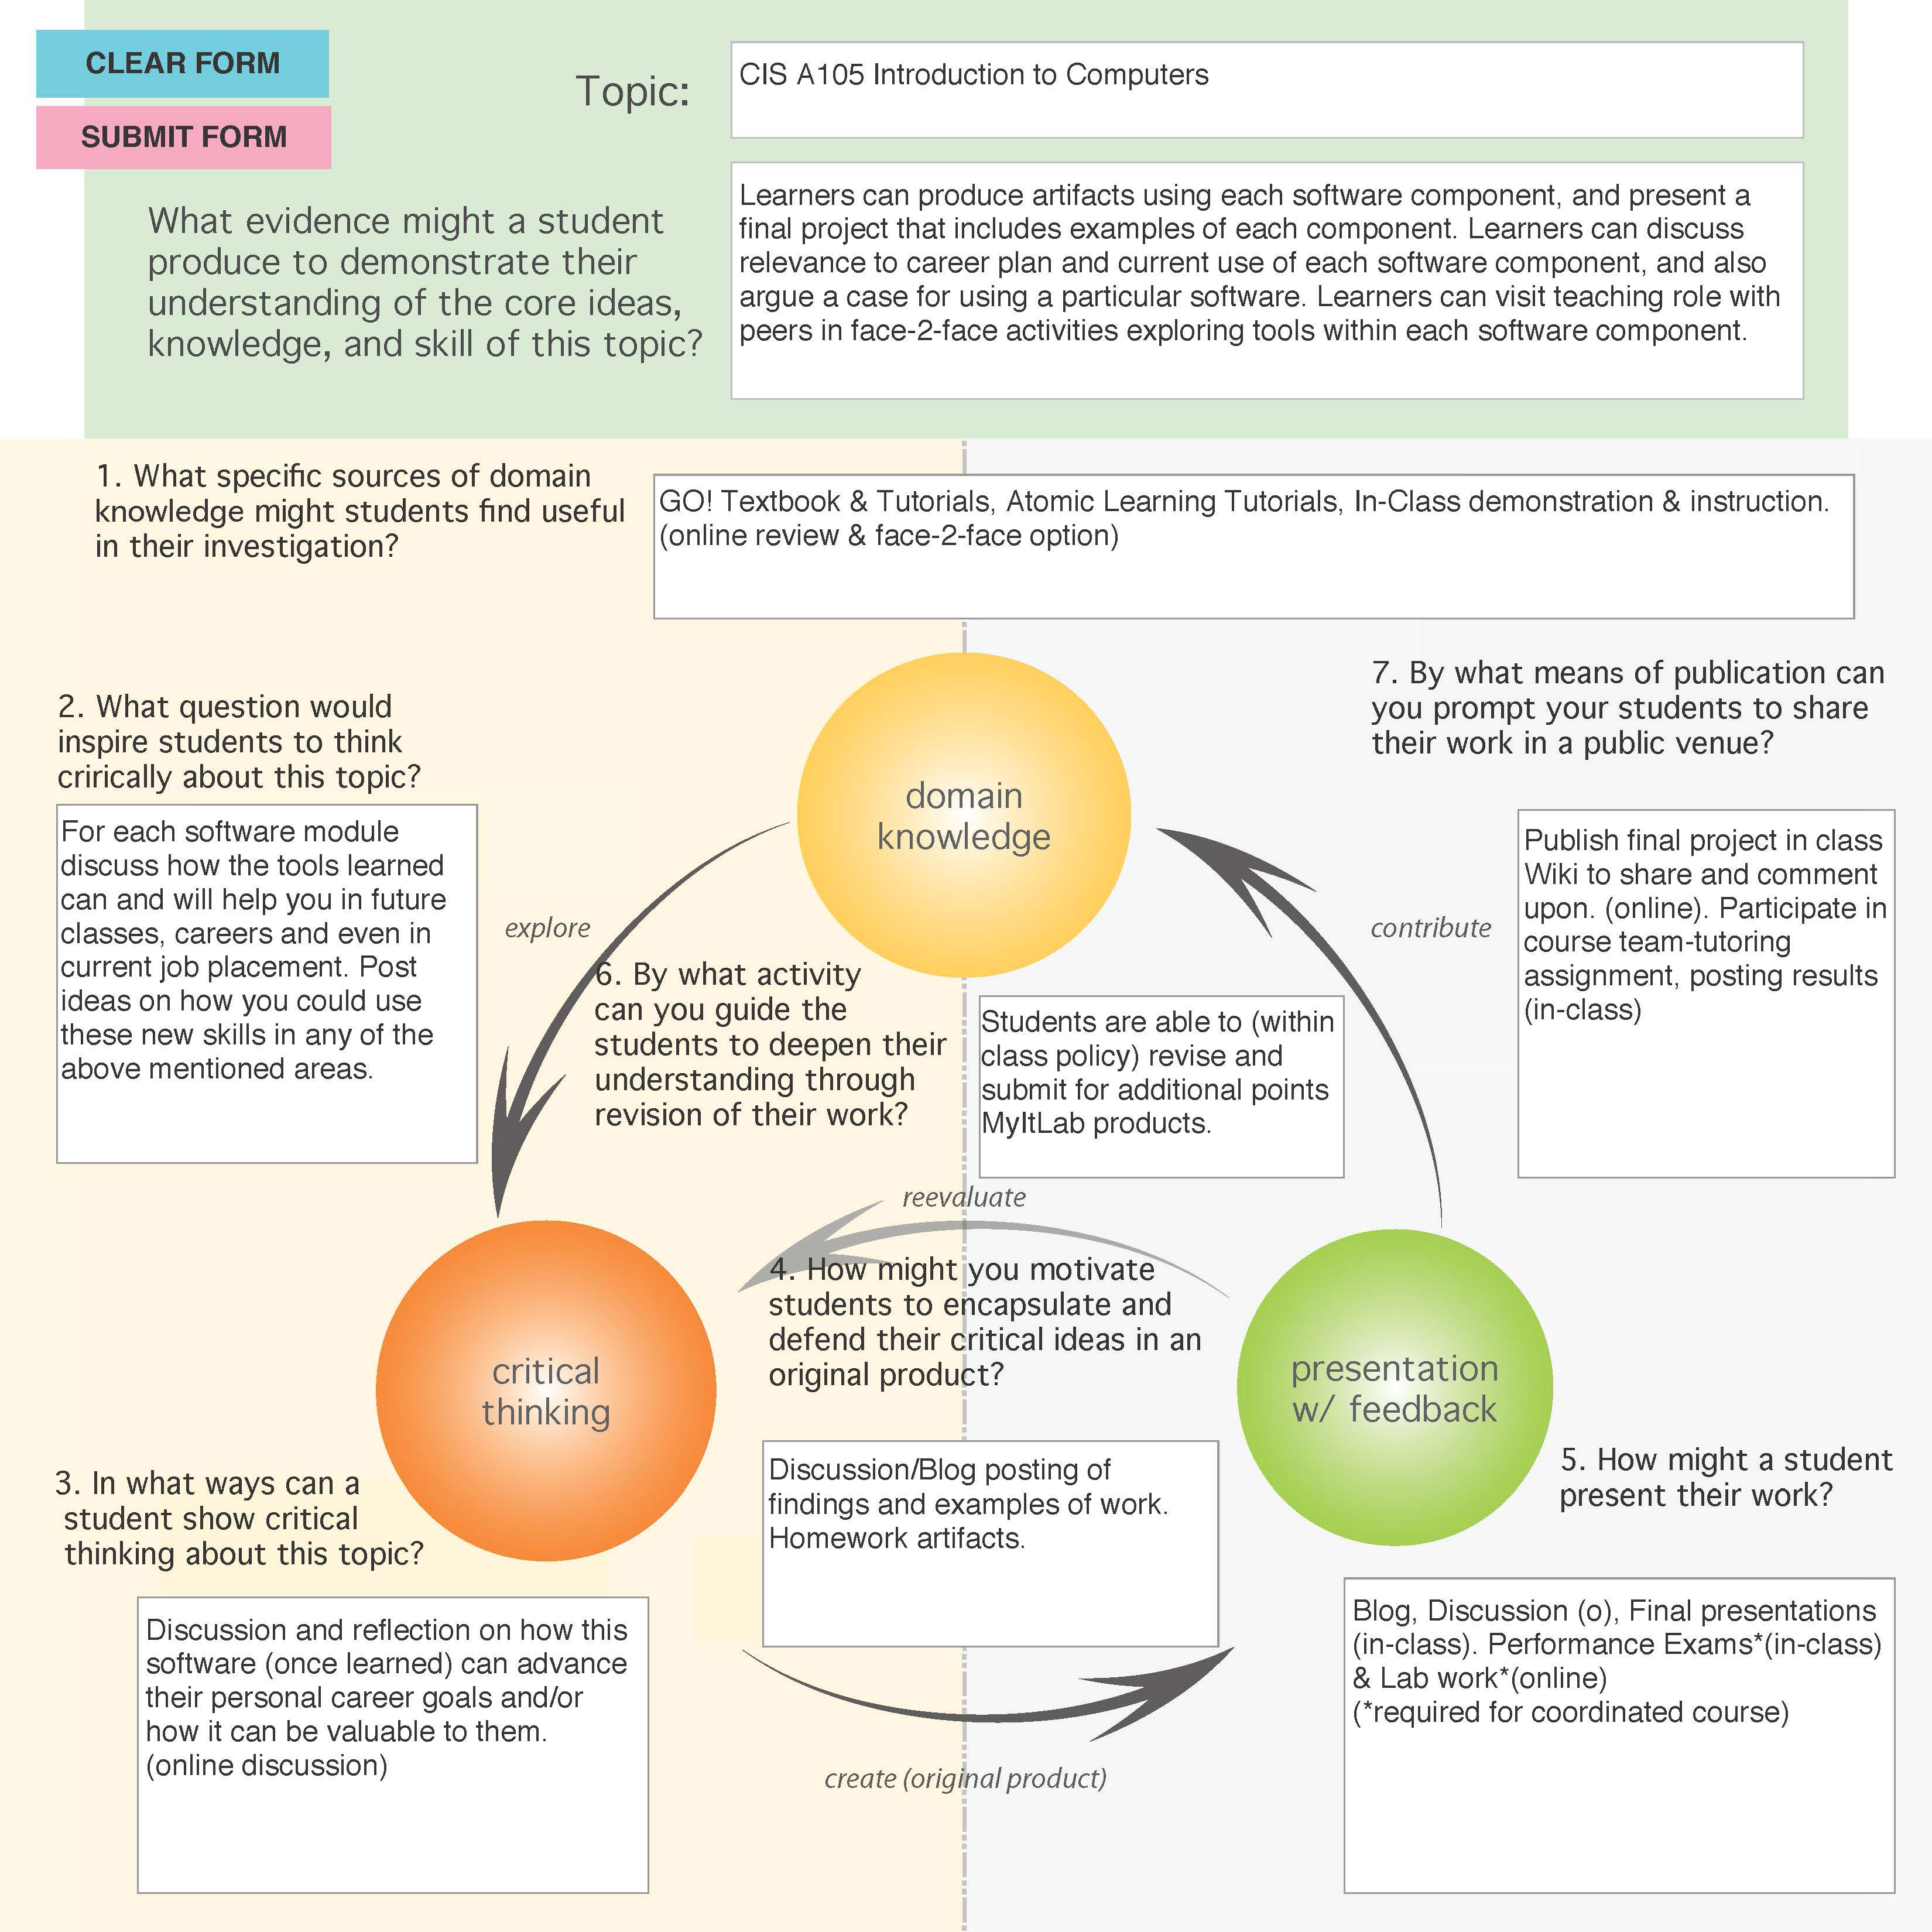
Sources: http://ctl.utexas.edu/teaching/engagement/experiential & http://commons.uaa.alaska.edu/networkwide-posts

